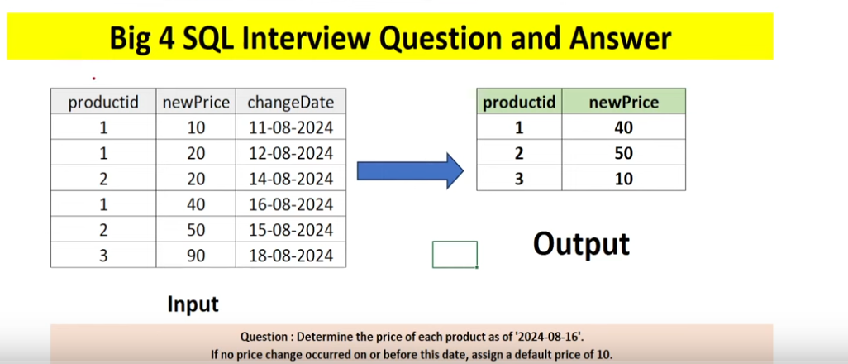

Try in SQL server Management Studio
This can be downloaded and sample DBs can also be imported freely into your local machine for practice and learning.
Link:
https://learn.microsoft.com/en-us/sql/samples/adventureworks-install-configure?view=sql-server-ver16&tabs=ssms

CREATE TABLE ProductPriceChanges (
ProductID INT NOT NULL, -- Product identifier
NewPrice INT NOT NULL, -- Price with two decimal places
ChangeDate DATE NOT NULL -- Date when the price changed
);
INSERT INTO ProductPriceChanges (ProductID, NewPrice, ChangeDate)
VALUES
(1, 10, '2024-08-11'),
(1, 20, '2024-08-12'),
(2, 20, '2024-08-14'),
(1, 40, '2024-08-16'),
(2, 50, '2024-08-15'),
(3, 90, '2024-08-18');

select * from ProductPriceChanges

with CTE as (
select *, row_number() over (partition by ProductID order by changeDate desc) as rn
from ProductPriceChanges
where changeDate<='2024-08-16'
)

select t1.ProductID,COALESCE(t2.newprice,10) as newprice from
(select distinct(ProductID) from ProductPriceChanges) t1
left join CTE t2 on t1.ProductID=t2.ProductID and rn=1 order by ProductID

